1. **What are the advantages of Bootstrap?**

Ans:-  
 **Advantages of Bootstrap:-**

* **Responsive Design:** Bootstrap is built with a mobile-first approach, ensuring that websites and applications look good and function well on devices of all sizes. It provides a responsive grid system and responsive utility classes for easy adaptation to various screen sizes.
* **Consistency:** Bootstrap provides a consistent and uniform look and feel across different browsers and devices. This helps in maintaining a cohesive design and user experience, reducing the need for extensive testing and adjustments for different platforms.
* **Pre-designed Components:** Bootstrap comes with a variety of pre-designed and pre-built components like navigation bars, modals, carousels, and more. These components save developers time and effort, allowing them to focus on customizing and fine-tuning rather than starting from scratch.
* **Easy Customization:** While Bootstrap provides a set of default styles and components, it is highly customizable. Developers can easily override the default styles and customize the components according to the project's specific design requirements.

1. **What is a Bootstrap Container, and how does it work?**

**Ans:-.container:-**

* The **.container** class creates a fixed-width container that is responsive and adapts its width based on the screen size.
* It has a fixed max-width at each responsive breakpoint, ensuring that the content doesn't stretch too wide on larger screens.
* This container is suitable for designs where you want to limit the maximum width of the content.

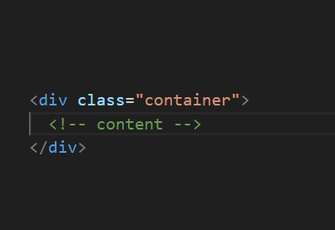

**.container-fluid:**

* The **.container-fluid** class creates a full-width container that spans the entire width of the viewport.
* It adjusts its width based on the screen size, making it suitable for designs where you want the content to occupy the full width of the screen.

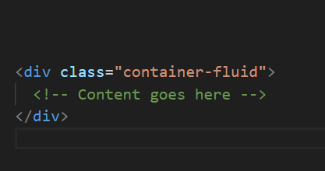

**How it works:-**

* The container acts as a wrapper for the main content of your webpage.
* It is styled with CSS to provide padding and manage the layout based on the chosen container class (**.container** or **.container-fluid**).
* Inside the container, you can use Bootstrap's grid system to create rows and columns, allowing you to organize and structure your content in a responsive way.

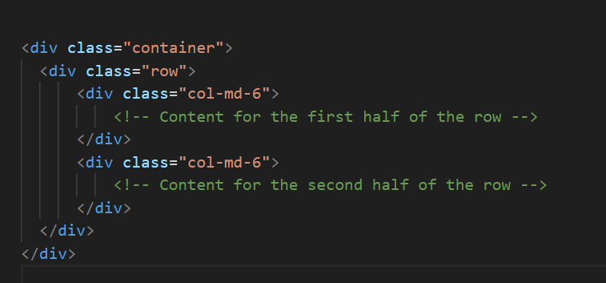

**3 .What are the default Bootstrap text settings?**

**Ans:- Text Alignment:-**

* **.text-left: Aligns the text to the left.**
* **.text-center: Centers the text.**
* **.text-right: Aligns the text to the right.**
* **.text-justify: Justifies the text.**

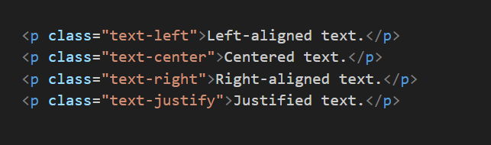

**Font Weight:**

* **.font-weight-bold: Sets the text to bold.**
* **.font-weight-normal: Resets the font weight to normal.**

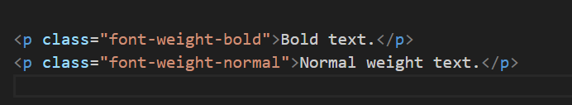

**Text Color:-**

* **.text-primary, .text-secondary, .text-success, .text-danger, .text-warning, .text-info, .text-light, .text-dark, .text-muted, .text-white:**

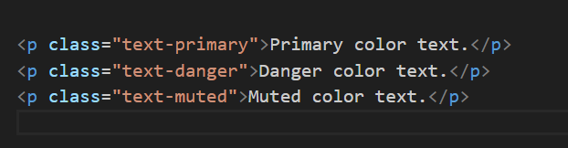

**4. What do you know about the Bootstrap Grid System?**

* + **12-Column Layout:**

The grid system is based on a 12-column layout, meaning that the width of the page is divided into 12 equal parts. Developers can use these columns to create flexible and responsive designs.

* + **Rows and Columns:**

To create a grid layout, you use rows and columns. Rows are horizontal containers that hold the columns. Each row can have up to 12 columns. You can adjust the number of columns for different screen sizes using Bootstrap's responsive classes.

* + **Responsive Classes:**

Bootstrap provides responsive classes to control the visibility and behavior of columns on different devices. These classes include col- (for extra small devices), col-sm- (small devices), col-md- (medium devices), and col-lg- (large devices).

* **Alignment and Justification:**

Bootstrap allows you to align and justify content within columns using classes like justify-content-* and align-items-*.

**Container Types:-**

Bootstrap offers two types of containers: .container and .container-fluid. The .container class creates a fixed-width container, while the .container-fluid class creates a full-width container that spans the entire viewport.

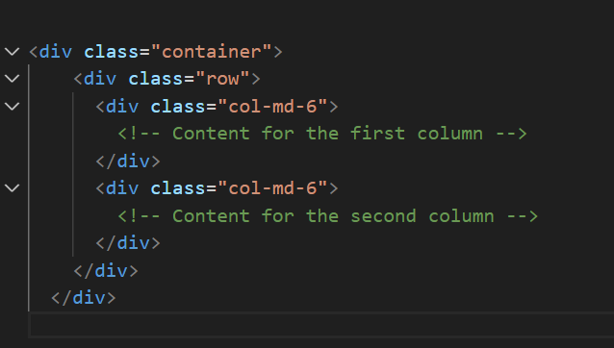

**5. What is the difference between Bootstrap 4 and Bootstrap 5**

**Bootstrap 4:**

1. Flexbox-Based Grid System: Bootstrap 4 primarily utilizes the Flexbox layout model for its grid system.
2. jQuery Dependency: Bootstrap 4 depends on jQuery for certain features and functionalities, such as handling some of the interactive components and plugins.
3. Sass Support: Bootstrap 4 is built using the Sass preprocessor, making it easier for developers to customize the framework using variables and mixins.
4. Icon Library: Bootstrap 4 includes the Glyphicons icon library by default.

**Bootstrap 5:**

1. Switch to Vanilla JavaScript: Bootstrap 5 has removed the jQuery dependency, making it more lightweight and modern. Interactive components are now implemented using plain JavaScript.
2. Improved Grid System: While Bootstrap 5 still uses a 12-column grid system, it has introduced a new grid system called the "Fluid Container" that replaces the need for the .container and .container-fluid classes. This simplifies the structure of the layout.
3. Dropped IE 10 and 11 Support: Bootstrap 5 no longer supports Internet Explorer 10 and 11. It focuses on modern browsers.
4. Customization Improvements: Bootstrap 5 has improved customization options and documentation.

**6.What is a Button Group, and what is the class for a basic Button Group?**

**Ans:-** In Bootstrap, a basic button group is created using the .btn-group class. Here's a simple example of a horizontal button group:

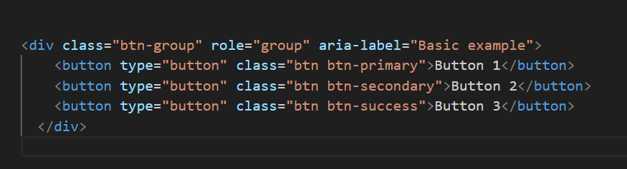

The <div> element has the class btn-group, indicating that it is a button group.

Each <button> inside the group has its own styling based on the Bootstrap button classes, such as btn btn-primary, btn btn-secondary, and btn btn-success.

**7.How can you use Bootstrap to make thumbnails?**

**Ans:-**

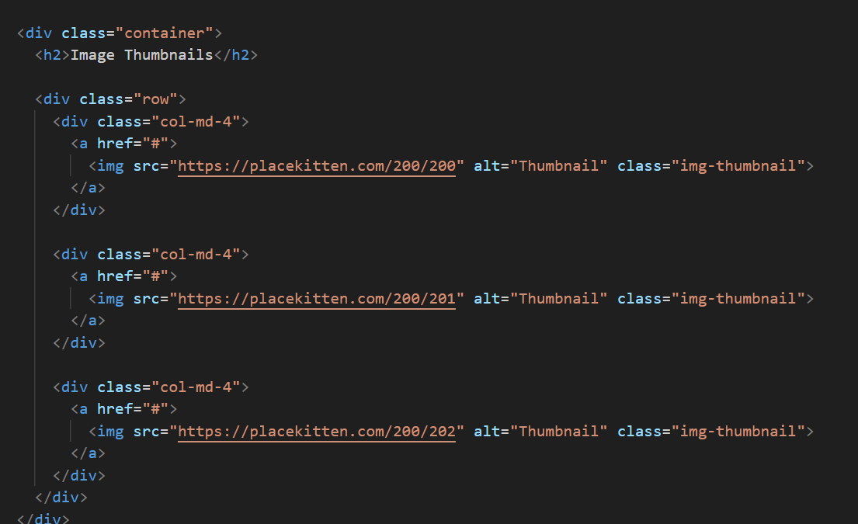

The <img> elements within the <a> tags represent the thumbnails.

The class="img-thumbnail" is added to each <img> element to apply the Bootstrap styling for thumbnails.

**8. In Bootstrap 4, what is flexbox?**

**Ans:-**

1. **Flexible Container:**
   * In a Flexbox layout, the parent container becomes a flex container, and its direct children become flex items. The container manages the layout of its items along a flex line.
2. **Flex Direction:**
   * The **flex-direction** property determines the direction of the main axis in the flex container. In Bootstrap 4's grid system, the default direction is set to **row** for horizontal layouts.
3. **Flex Items:**
   * The child elements within a flex container are referred to as flex items. In Bootstrap 4, the grid system columns are flex items.
4. **Flex Wrap:**
   * The **flex-wrap** property controls whether the flex container should wrap its contents to multiple lines if there isn't enough space. Bootstrap 4 often utilizes **flex-wrap: wrap** for its grid system to create responsive layouts.
5. **Alignment:**
   * Flexbox provides powerful alignment capabilities, allowing for the alignment of items both horizontally and vertically within the container. Bootstrap 4 uses these alignment features extensively to create responsive and well-aligned layouts.

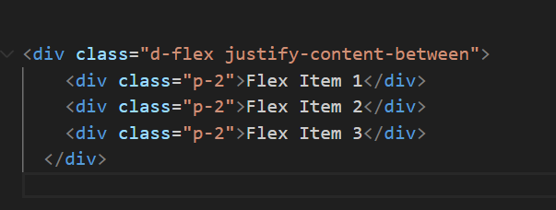

**9.How can one create an alert in Bootstrap?**

**Ans:-** 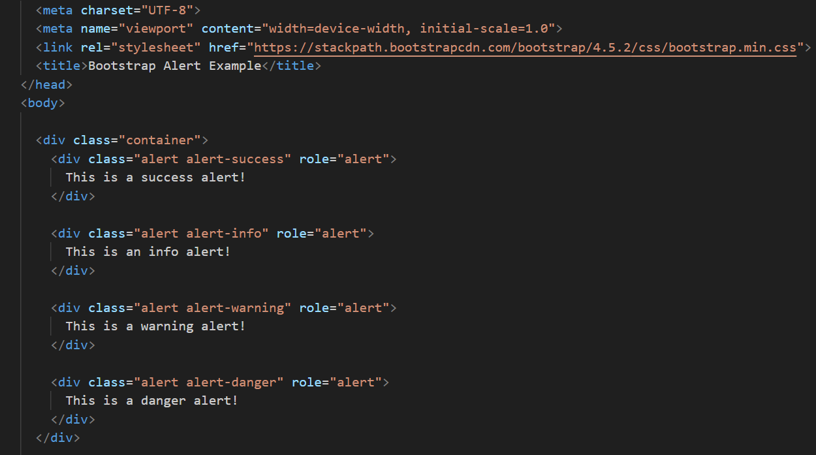

The <div> elements with the class alert represent the alerts.

Additional contextual classes like alert-success, alert-info, alert-warning, and alert-danger are used to specify the type of alert and apply corresponding styling.

**10.What is a bootstrap card and how would you create one?’**

**Ans:-** A Bootstrap card is a flexible and extensible content container that allows you to group various types of content in a visually appealing and organized way. It's a component provided by the Bootstrap framework, which is a popular front-end framework for building responsive and mobile-first websites. Bootstrap cards are versatile and commonly used for displaying information, such as product details, blog posts, user profiles, and more.

**Create bootstrap card:-**